SAGUI Trading Properties – Testing & Overall Information

Introduction

The SAGUI has been enhanced with the ability to add/edit/delete server-side Trading Properties. Previously this was only achievable via AR (Admin Request) script on the Business Server.

As of November, 2003, there are 21 Trading Property types. All Trading Property types are set as a “default” for a given Trading Session; some also have the ability to be set at the Product Class level, as follows:

- Allocation Strategy (for Product Class)
- Book Depth Size (for Product Class)
- Contingency Time To Live (for Product Class)
- Continuous Quote Period For Credit
- DPM Participation Percentage (for Product Class)
- Exchange Prescribed Width (for Product Class)
- Fast Market Spread Multiplier (for Product Class)
- IPP Minimum Size (for Product Class)
- IPP Tradethrough Flag (for Product Class)
- Minimum Quote Credit Default Size
- Minimum Size for Block Trade (for Product Class)
- Opening Period Time Range
- Opening Price Delay
- Opening Price Rate
- Pre-Closing Time Period
- Prescribed Width Ratio
- Quote Lock Notification Timer (for Product Class)
- Quote Lock Timer (for Product Class)
- Quote Trigger Timer (for Product Class)
- RFQ Response Ratio
- RFQ Timeout (for Product Class)

Properties can be added or deleted according to the following rules

- Only Trading Property types that can be set for Product Class can have Properties added or deleted
- Only Properties for specific classes can be added or deleted
- The default Property may be changed, but never deleted

There are two different ways to view/edit Trading Properties in the SAGUI: by Session/Class (will show all Properties for a given Trading Session or by a specific Product Class in that session); or by Property (will show all Properties for a given Property Type). Adds and deletes may only be done in this Property view.

Why can I only add/delete in Property View?
This was done to address the issue of default Property Types; when the system return a listing of all Properties for a given Product Class, it will always return a complete set of 16 Property Types. For those Property Types that do not have a Property defined for that Product Class (either because the Type doesn’t take Class-specific settings, or simply because a setting wasn’t defined for that Class), the system simply returns the default. However, it is impossible to know which Property is the “default” and which is “Product Class-specific” without looking in the “Property view” screen. Users might therefore attempt to inadvertently remove this Property, not realizing it was the default.

Trading Property Data

Different Trading Property types contain different data. For the most part, Trading Properties store simple data elements such as whole number integers, decimal numbers, or boolean true/false values. However, some Trading Property types are more complex. Here are the different types, what data they contain, and the Trading Property types that correspond to them:

Data Type | Data Contained In Type | Properties Using Type
Integer (Java int, CORBA long) | - Whole-number integer | - Book Depth Size  - Continency Time to Live  - Continuous Quote Period for Credit  - IPP Minimum Size  - Minimum Quote Credit Default Size  - Minimum Size for Block Trade  - Opening Price Delay  - Opening Price Rate  - Quote Lock Timer  - Quote Lock Notification Timer  - Quote Trigger Timer  - RFQ Timeout
Decimal (Java double, CORBA double) | - Decimal number | - DPM Participation Percentage  - Fast Market Spread Multiplier  - Prescribed Width Ratio  - RFQ Response Ratio
True/False (Java boolean, CORBA boolean) | - Boolean value | - IPP Tradethrough Flag
Allocation Strategy (Java/CORBA AllocationStrategyStruct) | - Default Strategy Code (integer)  - Prioritized Strategy Codes (0…n integers) | - Allocation Strategy

Data Type | Data Contained In Type | Properties Using Type
Exchange Prescribed Widths (Java EPWStruct array, CORBA EPWStructSequence) | 0…n Exchange Prescribed Widths, which in turn contain:  - Minimum Bid Range (double)  - Maximum Bid Range (double)  - Maximum Allowable Spread (double) | - Exchange Prescribed Width
Time Range (Java/CORBA TimeRangeStruct) | - Upper Limit (integer)  - Lower Limit (integer) | - Opening Period Time Range  - Pre-Closing Time Period

Viewing and Entering Data

Trading Properties data is edited via a dialog box that displays data for a given Property. The dialog contains relatively intuitive GUI components to facilitate data entry and minimize errors, as follows:

- For integer and double data types, the dialog simply displays a textfield where the numeric information can be entered. The field is “smart” enough to only allow digits (and decimal points in the case of doubles):

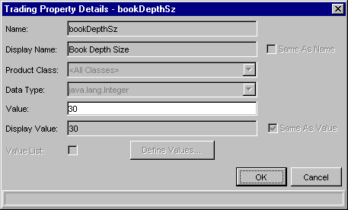

- For boolean types, the dialog displays a checkbox representing “true/false”; the display value simply displays a textual representation of the boolean state:

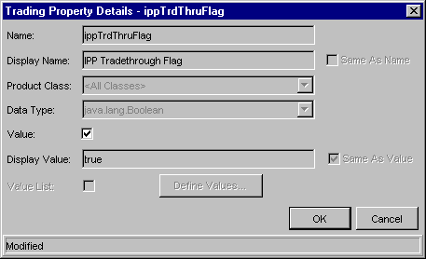
NOTE: The “Same As Value” checkbox and the “Value List” components are disabled; this functionality will be turned on in a future release, when server-side functionality is enhanced to support it.

- For Time Ranges, the dialog displays textfields for Upper and Lower Limits:

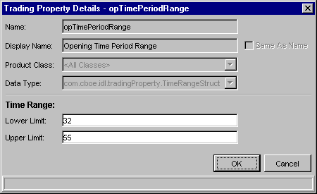

- For Exchange Prescribed Widths, the dialog displays a table of Exchange Prescribed Widths.
  - These can be edited by clicking on a table row and editing the values in the textfields below (the table itself is not editable, but will refresh with changes in the textfields).
  - New EPWs can be added by clicking the “Add EPW” button, which will add a new row to the table and select it for data entry in the textfields:

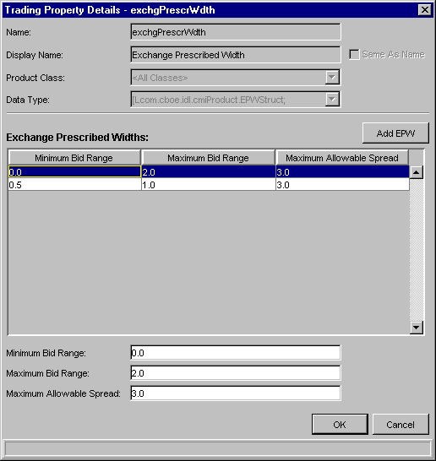

- For Allocation Strategies, the dialog displays a list of Prioritized Strategies, and a combobox for selecting Default Strategy.
  - Prioritized Strategies may be added and removed by clicking the “Add/Remove…” button (the list itself is not editable). When clicked, this button brings up a second dialog that allows basic “chooser-style” editing of Prioritized Strategies; use the arrow buttons to move Strategy Codes in and out, and click “OK” in the dialog when done:
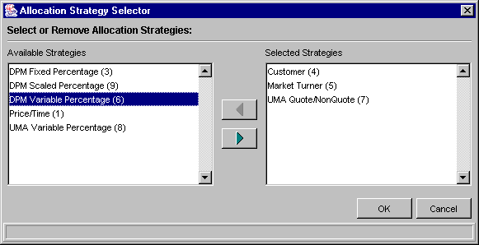

  - Default strategy may be changed using the combobox, which displays a drop-down list of all available Strategy codes.
  - Meaningful values for the Strategy codes are displayed in both list and combobox, along with the actual strategy code in parentheses (in the main window’s table, only the codes are shown to conserve space).

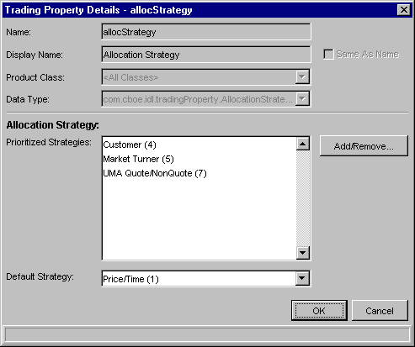

Special Business Rules

Some Trading Properties have rules as to what data may be entered; although for the most part, these rules are enforced through the GUI’s design, please note them for testing purposes:

Allocation Strategy
- Default Strategy may only be “Price/Time (1)” or “Pro Rata (2)”. These are the only selections available from the combobox
- Prioritized Strategies may be any combination of codes other than the Default Strategy selections. The GUI atuomatically sorts the codes to place them in numerical order

NOTE: Though the code does not prevent the end-users from entering any combination of allocation strategy codes, you should know the business logic behind which allocation strategies you want employed. For example, there are two types of UMA allocation strategies; it would not make sense to employ both in succession

Exchange Prescribed Width
- The first EPW must have a Minimum Bid Range value of 0
- The next-higher EPW must have a Minimum Bid Range equal to the Maximum Bid Range of the previous EPW
- There cannot be a gap or overlap in EPW ranges
- The Maximum Allowable Spread cannot exceed 3.0
- The Maximum Allowable Spread must follow these rules:
  - For bid ranges from 0 to 1.99, the Maximum Allowable Spread cannot be greater than 0.250
  - For bid ranges from 2 to 4.99, the Maximum Allowable Spread cannot be greater than 0.375

Testing Trading Properties

- Displaying All Properties for a Given Session/Class

Step | Description | Expected Result
1 | Launch and login to the SAGUI as a Help Desk user | SAGUI starts up
2 | From the Start menu, select Trading Properties – Class View – Create New Window | The Trading Properties Class View window opens
3 | Select W_MAIN Trading Session from the combobox at the top of the window | The Product Type and Product Class comboboxes automatically display with default values (OPTION and <All Classes>); after a short delay, Trading Properties display in the table and the status bar indicates that all 21 have retrieved successfully
4 | Select all other Trading Sessions, and within Trading Sessions, change the Product Class as well | Trading Properties table changes to display Properties for different Sessions and Classes; NOTE that when a Session is changed, the default <All Classes> Product Class is displayed

- Displaying All Properties for a Given Property Type

Step | Description | Expected Result
1 | Launch and login to the SAGUI as a Help Desk user | SAGUI starts up
2 | From the Start menu, select Trading Properties – Property View – Create New Window | The Trading Properties Property View window opens
3 | Select W_MAIN Trading Session from the combobox at the top of the window | Combobox selection changes
4 | Select a Property Type from the Property Type combobox | Trading Properties table displays all Properties for that given Property Type; see above for listing of Property Types that may contain Properties by Product Class
5 | Repeat step 4 for all remaining Properties | Properties display as per listing above; NOTE that all Property Types MUST contain a default <All Classes> value

- Modifying & Saving a Numeric Property

Step | Description | Expected Result
1 | Repeat steps 1 thru 3 of Test 1 | See above
2 | Double-click on a table row, or select the row and click on the “Details…” button, corresponding to one of the Integer or Decimal Properties listed in Trading Property Data, above | The Detail Dialog displays, with the following Property data:  - Name (disabled)  - Display Name (disabled)  - Product Class (disabled)  - Data Type (disabled)  - Value (enabled)  - Display Value (disabled)
3 | Modify the Property data, and click “OK” in the dialog | Data changes in the table and status bar indicates “Modified”
4 | Click “Save” in the window | Data saves; message displays in window status bar indicating save was successful
5 | Repeat steps 2 thru 4 for all other Integer and Decimal Properties | Data modifies and saves successfully

- Modifying & Saving a Boolean Property

Step | Description | Expected Result
1 | Repeat steps 1 thru 3 of Test 1 | See above
2 | Double-click on a table row, or select the row and click on the “Details…” button, corresponding to one of the Boolean Properties listed in Trading Property Data, above | The Detail Dialog displays, with the following Property data:  - Name (disabled)  - Display Name (disabled)  - Product Class (disabled)  - Data Type (disabled)  - Checkbox representing true/false value (enabled)  - Display Value (disabled)
3 | Click on the checkbox, and click “OK” in the dialog | Data changes in the table and status bar indicates “Modified”
4 | Click “Save” in the window | Data saves; message displays in window status bar indicating save was successful

- Modifying & Saving a Time Range Property

Step | Description | Expected Result
1 | Repeat steps 1 thru 3 of Test 1 | See above
2 | Double-click on a table row, or select the row and click on the “Details…” button, corresponding to one of the Time Range Properties listed in Trading Property Data, above | The Detail Dialog displays, with the following Property data:  - Name (disabled)  - Display Name (disabled)  - Product Class (disabled)  - Data Type (disabled)  - Lower Limit (enabled)  - Upper Limit (enabled)
3 | Enter whole-number numeric values in Lower Limit and Upper Limit fields, and click “OK” in the dialog | Data changes in the table and status bar indicates “Modified”; fields should ONLY allow whole number input
4 | Click “Save” in the window | Data saves; message displays in window status bar indicating save was successful
5 | Repeat steps 2 thru 4 for all other Time Range Properties | Data modifies and saves successfully

- Modifying & Saving Allocation Strategy Property

Step | Description | Expected Result
1 | Repeat steps 1 thru 3 of Test 1 | See above
2 | Double-click on a table row, or select the row and click on the “Details…” button, corresponding to the Allocation Strategy Property listed in Trading Property Data, above | The Detail Dialog displays, with the following Property data:  - Name (disabled)  - Display Name (disabled)  - Product Class (disabled)  - Data Type (disabled)  - Prioritized Strategy List (view-only)  - “Add/Remove” button (enabled)  - Default Strategy (enabled)
3 | Click on the “Add/Remove” button | The Allocation Strategy Selector dialog displays
4 | In the Allocation Strategy Selector dialog , select items in the left and/or right lists, and use the left- or right-arrow buttons to “move” the items from one list to another | Items move as expected; NOTE that the right-hand list contains the selections of Prioritized Strategy Codes that will display in the Detail Dialog
5 | Click “OK” in the Allocation Strategy Selector dialog | Dialog disappears, and Detail Dialog’s Prioritized Strategy list is updated; Detail Dialog’s status bar displays “Modified”
6 | Select a different Default Strategy value using Default Strategy combobox | Value changes as expected
7 | Click “Save” in the window | Data saves; message displays in window status bar indicating save was successful

- Modifying & Saving Exchange Prescribed Width Property

Step | Description | Expected Result
1 | Repeat steps 1 thru 3 of Test 1 | See above
2 | Double-click on a table row, or select the row and click on the “Details…” button, corresponding to the Exchange Prescribed Width Property listed in Trading Property Data, above | The Detail Dialog displays, with the following Property data:  - Name (disabled)  - Display Name (disabled)  - Product Class (disabled)  - Data Type (disabled)  - Exchange Prescribed Width table (display-only)  - “Add EPW” button (enabled)  - Minimum Bid Range textfield (initially disabled)  - Maximum Bid Range textfield (initially disabled)  - Minimum Allowable Spread textfield (initially disabled)
3 | Click on a table row | Minimum Bid Range, Maximum Bid Range, and Minimum Allowable Spread textfields all become enabled, and display values corresponding to the table row
4 | Modify values in the textfields | Values modify in the table, and the Detail Dialog’s status bar displays “Modified”
5 | Click “Save” in the window | Data saves; message displays in window status bar indicating save was successful
6 | Click the “Add EPW” button | A new table row is created, with all-0.0 values; row is selected and row values display in textfields below
7 | Modify values in the textfields | Values modify in the table, and the Detail Dialog’s status bar displays “Modified”
8 | Click “Save” in the window | Data saves; message displays in window status bar indicating save was successful

- Adding a Property for a Product Class

Step | Description | Expected Result
1 | Repeat steps 1 thru 4 of Test 2; ensure that the Property you select can be set for Product Class, as described in the Introduction | See above
2 | Click the “Add” button at the bottom of the Property View Window | Detail Dialog displays with empty Property information
3 | Fill in the appropriate fields; ensure that you select a Product Class that is NOT already in the table | Fields populate as expected (see tests above for different Property types)
4 | Click “OK” in the Detail Dialog | Row is added to table, and window’s Status Bar displays “Modified”; NOTE that if you attempt to add a Property whose Product Class is already in the table, you will get a warning and nothing will be added to the table
5 | Click “Save” in the window | Data saves; message displays in window status bar indicating save was successful
6 | Repeat steps 1 thru 5 for all other Property types that can be set for Product Class | NOTE that in all Property Types that CANNOT be set for Class, the “Add” button is disabled

- Adding a Property for a Product Class – Alternate Method

Step | Description | Expected Result
1 | Repeat steps 1 thru 3 of Test 1 | See above
2 | Repeat steps 1 thru 4 of Test 2; select a Property that can be set for Product Class, as described in the Introduction | See above
3 | Go back to the Class View window you opened as part of step 1; ensure you can still see the Property View window you opened in step 2 | Both windows display on the screen
4 | In the Class View window, select a Product Class that does NOT appear in the table of Trading Properties in the Property View window | The Trading Property in the Class View window displays the default (<All Classes>) value
5 | In the Class View window, select the Trading Property row corresponding to the Property Type selected in the Property View window. Click on the “Details” button (or simply double-click the row) | Detail Dialog displays with Property information corresponding to the selected row in the table
6 | Modify information in the Detail Dialog, following the Special Business Rules, if applicable; click “OK” in the dialog when completed | Data modifies in the table and the “Modified” indicator displays in the Class View window’s status bar
7 | Click “Save” in the Class View window | Data saves; message displays in window status bar indicating save was successful
8 | Reselect the Trading Property type in the Property View window | The Property with the new value for the specified Product Class displays as a row in the Property View table

- Removing a Property for a Product Class

Step | Description | Expected Result
1 | Repeat steps 1 thru 4 of Test 2; ensure that the Property you select can be set for Product Class, as described in the Introduction | See above
2 | Select a row in the table | Table row displays as selected; NOTE that if you select the <All Classes> row, “Delete” button will disable as you CANNOT delete the default Property setting
3 | Click the “Remove” button at the bottom of the Property View Window | Confirmation disalog displaysn
4 | Click “OK” in the confirmation dialog | Table row deletes; another confirmation indicates that you must save data for deletion to be persisted to database
5 | Click “Save” in the window | Data saves; message displays in window status bar indicating save was successful
6 | Repeat steps 1 thru 5 for all other Property types that can be set for Product Class | NOTE that in all Property Types that CANNOT be set for Class, the “Add” button is disabled

